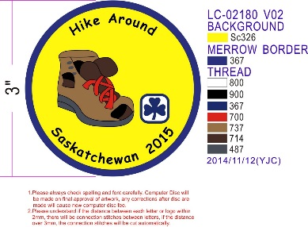

HIKE AROUND SASKATCHEWAN Crest Request Form

**NEW 2015 Crests Are Available For Purchase**

Remember to take photos of your hiking event and send them to: [publicrelations@girlguides.sk.ca](mailto:publicrelations@girlguides.sk.ca) or [provincial@girlguides.sk.ca](mailto:provincial@girlguides.sk.ca).

Unit Participating: ___________________________________ Number of Participants: ___________

District: ______________________________________ Area: ______________________________

Date of Hike: ________________________ Location of Hike: _______________________________

Complete mailing address for crests: __________________________________________________

______ Crests @ $2 each = $ _________ Amount Enclosed: ________________

Girl Guides of Canada-Guides du Canada, Saskatchewan Council

200-1530 Broadway Avenue, Regina, SK S4P 1E2

* If you hiked in 2014, there are some Crests available to purchase.
* Place your order now & please indicate that you want the 2014 Crests!